

**Concordia Institute for Information System Engineering (CIISE) Concordia University.**

**INSE 6280: Quality Assurance for Systems Engineering**

**PROJECT REPORT**

**ON**

**HOME AUTOMATION USING RASPBERRY PI**

**Submitted to:**

**Professor Dr. Ayda Basyouni**

**April 04, 2019**

**Submitted by:**

|  |  |
| --- | --- |
| **Name** | **Student ID** |
| Manvir Singh | 40040143 |
| Mounika | 40055028 |
| Natasha Basutkar | 40081017 |
| Sushma Reddy Gurram | 40086757 |

Contents

1.Introduction 4

2. Face detection technology for Raspberry Pi 5

2.1. Home Automation Using Raspberry pi 5

3.Inputs and Outputs 5

4.Quality Factors: 6

5.Human Factors 7

5.1 Anthropometric factors 7

5.1.1 Camera 7

5.1.2 Touch pad 8

5.1.3 Button 8

5.2 Human Physical Effort 8

5.3 Human sensory factors 8

5.4 Reaction time 9

5.5 User-Friendly Design 9

5.6 OTA 9

6. Sustainability: 10

6.1 Material Analysis: 10

6.1.1 Raspberry Pi 10

6.1.2 GPIO Expansion Board 11

6.1.3 Camera controls: 11

6.1.4 Complete Unit to Hold Raspberry Pie, Door Locking System 12

6.2 Process Analysis 12

6.3 Analysis and Advantages from Sustainability Point of View 12

7.Reliability 12

7.1 Reliability Block diagram of Raspberry Pi and its components: 12

7.1.1 First Level of Decomposition 13

7.2.2 Second Level of Decomposition 13

7.2.3 Third Level of Decomposition 13

8.FMEA 14

8.1 FMEA Table 14

8.2 Fault tree Analysis 15

9. Maintainability 17

9.1 Economical Table 17

10.1 Conclusion & Future works 17

11. References 18

2

# 1.Introduction

This project focuses on “**Face recognition powered identity detection for home security using Raspberry Pi**”. As part of this project, we aim to provide security for home owners by allowing authorized individuals to enter the house premises. To implement this project, we have planned to integrate the Face detection technology to communicate with Raspberry Pi. This software will then compare the guest picture with the stored database and report to the user. The house owner can then decide whether the guest should be allowed or denied access.

This feature is also particularly useful for physically challenged persons as the system takes the picture of the guest, owner identifies the guest and the system eventually unlocks the door for the guest without any extra effort. Another important implementation is that we can use this to provide access for delivery persons, neighbors, etc and prevent unauthorized entry into our homes.

This device is designed to be economical to the end users and hence can be opted as a solution for home safety in comparison to the high end not so affordable home security solutions.

In addition to this, the entire unit is simple and safe to operate, contains elements that are eco-friendly to the environment along with being reliable and suitable to work in adverse weather conditions.

# 2. Face detection technology for Raspberry Pi

The face detection technology considered for our project is using the “**Haar Cascade Classifier**” which can be detect a face or any other objects based on a machine learning approach which includes training from a group of clicked pictures. These results are later used to detect other objects in other images.

# 2.1. Home Automation Using Raspberry pi

This system is composed of various components including a High-Definition video camera for Raspberry Pi 3, Raspberry Pi as a component itself to integrate and communicate with all other devices and the related software. The details are listed in the diagram below

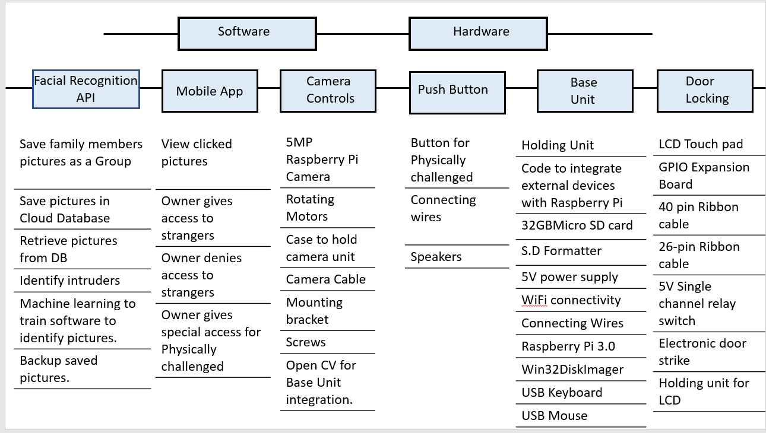

# 3.Inputs and Outputs

We have identified the inputs and outputs of this system to fully understanding its functionality and working. From the design perspective, the system processes could be viewed as follows :

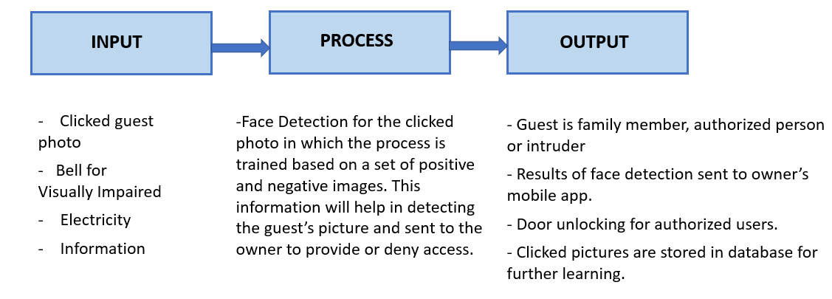

# 4.Quality Factors:

|  |  |  |
| --- | --- | --- |
| Quality Factor Evaluation | | |
| Performance | Efficiency | 1. Takes the pictures of the guests within seconds 2. Sends the pictures of the new guests to the owner within seconds 3. Stores the pictures of the authorized guests for a quick access 4. Supports physically challenged guests 5. In-built Wi-Fi |
| Integrity | 1. Provides access to authorized guests 2. Denies access to unauthorized guests 3. Owners can manage access authorization from anywhere in the world |
| Reliability | 1. Works in cold and hot weather 2. Available 24X7X365 |
| Survivability | 1. Data stored in cloud. Easily recovered in case of any disaster 2. Works in any temperature ranging from -70 Celsius to +70 Celsius |
| Usability | 1. One click for the guest to request for an authorization 2. Owners can authorize or deny entry in a single click 3. Ability for the owner to provide preauthorized access for selected guests 4. Preauthorized users do not require authorization from owner 5. Ability for the owner to remove the preauthorized access 6. Speakers for physically challenged |
| Design | Verifiability | 1. Using Internet access to update periodically |
| Maintainability | 1. Pre-authorized users can be managed 2. Manage users who can provide authorization to guests |
| Sustainability | 1. Products used in manufacturing this system are reusable and recyclable 2. Device is not harmful to the environment |
| Adaptation | Portability | 1. Plug and play 2. Weight of the device is 0.5 kilograms Easy to carry the device anywhere |
| Interoperability | 1. Integrated with multiple mobile devices. This is useful for the owners to operate the system from anywhere in the world |
| Flexibility | 1. With a few maintainable changes, it can be changed from face recognition to a four digit password |
| Expandability | 1. Provision to expand to a dual factor authentication like a PIN or a one-time password on the mobile |
| Reusability | 1. Same display can be used in case the system is expanded to a dual factor authentication in future |

# 5.Human Factors

Human factors, that influence the humans like comfort design, functional design and user-friendly design factors. It becomes the responsibility of the designer that he/she should be cautious of such factors like anthropometric characteristics, sensory factors, physiological and psychological factors and their interactions to reduce possibility of errors, accidents and loss of productivity becomes feasible. Human factors design applies information about human characteristics to the generation of objects, facilities and environments that we live in.

## 5.1 Anthropometric factors

There are certain things that need to be adjusted and cared about related to the physical aspects of the human body. There are not so many physical factors that should be cared about in relation to Face recognition related project except few important aspects that need to be addressed; we have used below for the same

* Camera
* Touch pad
* Button

## 5.1.1 Camera

As our project name defines it is face recognition powered identity detection so face recognition is the most important aspect as part of this project which is being performed by the camera attached to our Raspberry Pi. So, in relation to the Anthropometric factors, the camera should be placed at the proper location near the door so that it should have a best viewing angle which would help to get a perfect detection of the person in front of it. As far as possible, it should be placed as such that it should be undetectable by the person in front of it.

## 5.1.2 Touch pad

It is only feature which is related to the sensory input that is touch. The touch pad being used in the project should be highly sensitive so that it should give a smooth user experience to the user using it. Moreover, it should have smooth surface, quiet buttons and should be of appropriate size.

## 5.1.3 Button

As part of our project, we considered a substantial feature of handicapped users, i.e. if they need to open the door how would be interacting with the whole system. So, by taking into consideration that aspect we have employed a button in addition to the touch pad because button is most suitable for handicapped users. So, the button should be push-button type, it should be of appropriate size, shape and placed at a location which provides best user experience.

## Human Physical Effort

|  |  |
| --- | --- |
| **Product Performance** | **Human Factors Characteristic** |
| User-friendly experience | We used best touch pad and button keeping in mind both normal and handicapped persons. |
| Ease of operation | User give the input as per the directions given audibly and visually, so it is very easy to operate. |
| Sensory experience | All sensory aspects like hearing, sight and touch are taken into account thoroughly, i.e. camera, touch pad, etc. aid in covering such aspects. |
| Comfortability | User input devices are perfectly shaped and designed keeping in mind comfortability. |

## 5.3 Human sensory factors

There are a lot of things which have been taken into related to the human senses like hearing, touch, sight so that when the user uses the system, he/she should have perfect user experience for which the product has been designed for.

* The camera used in the product is a 5MP one which has an adjustable viewing angle and aids in providing the sight aspect of the human factors and sends clear and crisp pictures once request is received.
* The core of this product is that it has facial recognition software which is so advanced that which when receives a request from the user detects in seconds that whether the user is somebody from the authenticated persons that belong to the home and open the gates.
* Touch pad provides user a high-tech and smooth user experience which aids user visually by providing instructions and make it easy to use.
* There is also a speaker that aids the user in guiding him better by giving instructions like to wait, to press this button which indeed gives user a sound knowledge of what is happening.
* Specifically, for the handicapped users, there is a button which aids such users who needs special attention.
* There is also mobile app provided at the home owner’s end by which he/she grants or denies access.

## 5.4 Reaction time

The reaction time of the whole system is very short and fast. When a user requests for something, the camera immediately takes a picture and pass it to the face recognition software and processes the picture and compares with the one in database and gives response back. It depends upon the person to person, if the picture is of the authenticated person that matches the one in database then it opens up the gates within seconds otherwise it sends the picture to the home owner’s mobile app who grants or denies the access. The maximum average processing time is 2 minutes.

## 5.5 User-Friendly Design

Overall, the design is up to the mark and performs the functions as expected.

## 5.6 OTA

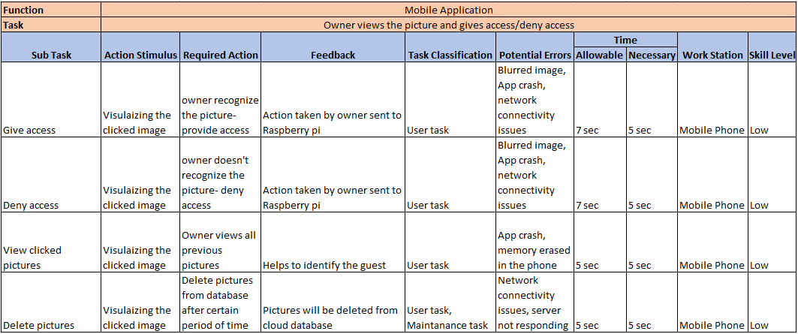

# **Sustainability:**

Sustainability focuses on meeting the needs of the current generation without compromising the ability of the future generations to meet their needs.To pursue sustainability is to create and maintain the conditions under which humans and nature can exist in productive harmony to support present and future generations. Sustainability is based on three pillars: environmental, social and economic.

For example, a factory that allows its waste to flow into a nearby body of water to avoid the short-term costs of proper disposal can cause expensive and significant long-term environmental damage. Sustainability encourages businesses to frame decisions in terms of years and decades rather than on the next quarter's earnings report and to consider more factors than simply the profit or loss involved.

## 6.1 Material Analysis:

According to sustainability purpose, below factors will be discussed and analyzed.

1. Reusing
2. Remanufacturing
3. Recycling
4. Wastage

### Raspberry Pi

The Raspberry Pi is essentially a cheap credit-card sized micro PC which was developed as a response to the lack of a computer-literate younger generation, attempting to make computing more accessible around the globe. It is a versatile product that can function as a proper desktop computer but is most generally used as an add-on functionality to smart devices.

Like most digital technology, the Raspberry Pi is composed of a variety of intricate components, each with its own set of raw materials and production processes. Its basic structure consists of a circuit board, Broadcom CPU, and various electrical connectors. The lifecycle of each of these components begins with variety of raw materials, which go through prolonged processes to end up a certain way in the finished product (Raspberry Pi Hardware).

### 6.1.2 GPIO Expansion Board

The GPIO expansion board is used to integrate various components and interfaces for connecting external accessory boards. It’s ideal for raspberry pi evaluation and development. Extension board uses 74hc244 and 74hc125 for level conversion and protects our circuit from burning. The frame of the Raspberry Pi is essentially the circuit board, whose two major constituents are fiber & glass, which provides insulation, and copper, which forms conductive pathways. Although it is difficult to pinpoint the birthplace of this fiberglass and copper, it is safe to assume that the sand used for fiberglass is being mined in sand quarries in Asia, which has led to its rapid economic growth and boom in construction. The sand that is found in most deserts is “unsuitable for concrete and land reclaiming since wind erosion process form round grains that do not bind well.” However, this extraction process plays a toll on the biodiversity; the volume being extracted is having a major impact on rivers, deltas and coastal and marine ecosystems (Green Facts).

### 6.1.3 Camera controls:

As digital cameras have taken over the market, recycling options have become more widespread. And unlike film cameras, digital cameras remain popular enough that you may be able to sell or give them away.

Digital cameras are manufactured with valuable materials that can be put back to use. Their microchips have gold and platinum, the wiring contains copper, and aluminum is used elsewhere in the device. Digital cameras also often come with rechargeable nickel-cadmium or lithium-ion batteries. They can be reused in other products. By recycling metals, manufacturers do not have to buy as many raw materials that are dug out of environmentally-damaging mines. All the components in the camera can be reused or recycled. We have different organizations to recycle the different components. Camera batteries can be recycled separately.

### 6.1.4 Complete Unit to Hold Raspberry Pie, Door Locking System

A wooden box is used to hold the complete unit of door locking system. Eco-friendly electronic anodized aluminum door strike is used to lock the door. It is not only the door strikes themselves that are distinguished by their environmental friendliness. Waste-free usage of the locks is also part of our concept – the so-called "zero waste policy", in which the materials are collected, recycled or re-used also consumes less energy.

## 6.2 Process Analysis

We need connecting wires, boards, camera to connect and software to communicate with each other. Communication happens between door locking, Raspberry Pi, interaction of software with home owner to provide authorization access to the guests.

## 6.3 Analysis and Advantages from Sustainability Point of View

Raspberry Pi A+’s power consumption is 1W at maximum, so it will take 1000 hours for a Raspberry Pi A+ to use 1kWh energy. It uses 8.76 kWh energy per year. Therefore, the cost of running a Raspberry Pi A+ a year is below $1.23 (assuming 14.08c/kWh). Raspberry Pi uses very little amount of electricity which releases a small amount of greenhouse gases.

# 7.Reliability

Reliability can be defined as “the ability of a system to consistently perform its intended function for a given period of time under suitable operating conditions”1.

Generally, raspberry Pi system are known to have perform well in terms of reliability. They are currently being deployed as servers that are required to run 24*7 and have expressed stable behaviour with minor faults reported. Another advantage of this system is it draws very little power, quickly reboots and be used for performing multitasking such as communicating with server, writing to the SD Card, etc. Raspberry Pi’s have been deployed to work in harsh weather conditions and they have executed the tasks far better than expected. The diagrams below describe the reliability from a high level initially and then decomposing them in smaller details.

## 7.1 Reliability Block diagram of Raspberry Pi and its components:

The system is divided into software and hardware components followed by the further level of decompositions.

## 7.1.1 First Level of Decomposition

## 7.2.2 Second Level of Decomposition

## 

## 

## 7.2.3 Third Level of Decomposition

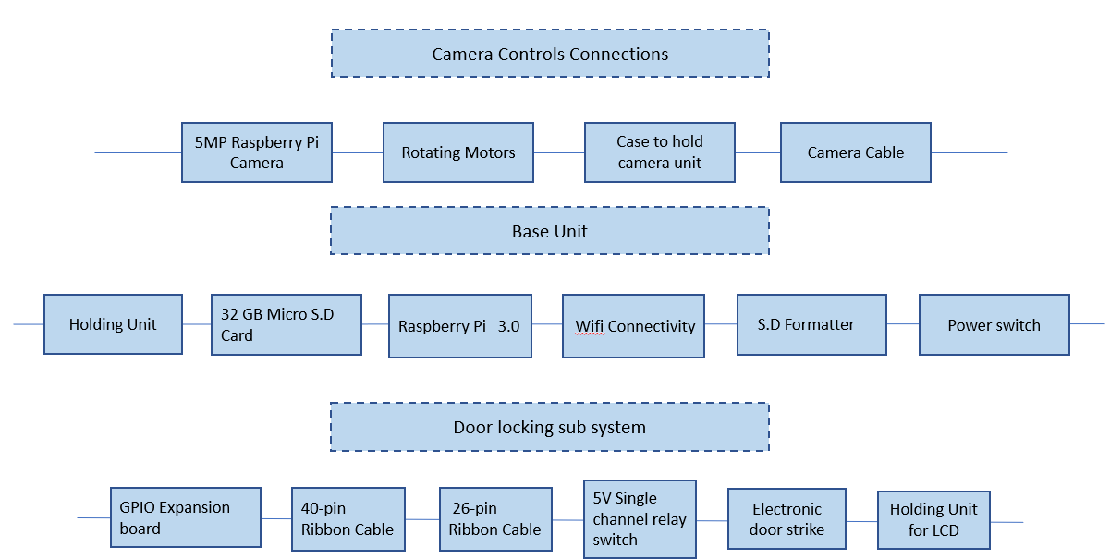

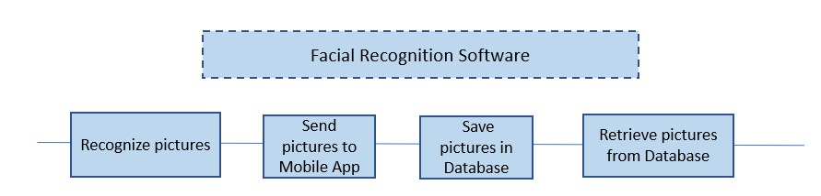

## 8.FMEA

Failure Mode Effect Analysis has been used to identify the possibility of errors/failures for the components used in our project. As part of this analysis, we could identify the following

* Facial Recognition Software can fail in identifying the picture and this would require human intervention along with providing more training data.
* The mobile application is a software component and can crash or have network connectivity issues in some cases.
* The connections between the LCD Touch pad, Push button might get disconnected and needs to be rechecked as part of maintenance activity.
* The camera holding unit should be strong to sustain the harsh weather conditions.

## 8.1 FMEA Table

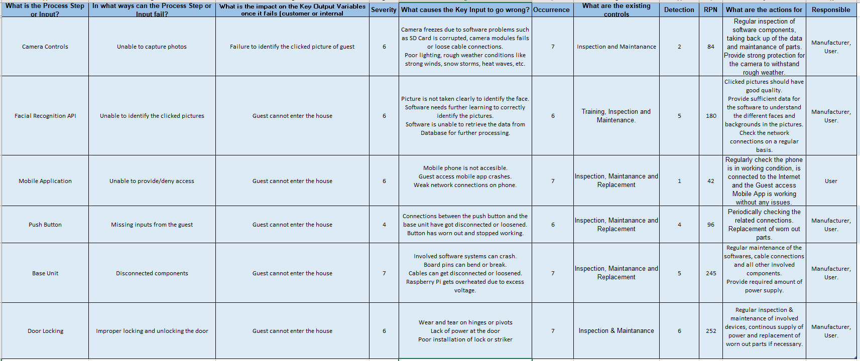The following FMEA chart for our projects is as follows.

## 8.2 Fault tree Analysis

Fault tree for Raspberry Pi System

Fault tree for Facial Recognition Software

Fault tree for Camera Controls:

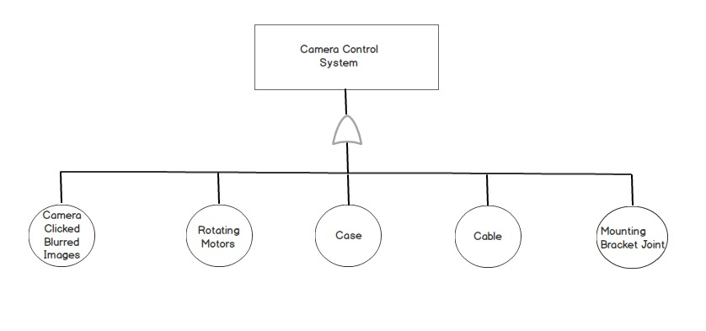

Fault tree for Mobile App system:

## 9. Maintainability

Maintainability plays a major role in any system. Maintenance of a product can be costlier than its development. Different types of maintainability are described below as per our project:

**Corrective Maintenance:** Raspberry Pi system can be set to reboot at regular intervals so as to reduce the errors.

**Preventive & Perfective Maintenance:** Adding the timely security patches for software upgrade of facial recognition and Mobile App to prevent it from corruption. We can also perform unscheduled booting of the system.

**Adaptation Maintenance:** Facial recognition and Camera are adaptive to the environment. Haar cascade classifier can blur the background and captures only the human facial features. Camera is installed with night vision.

## 9.1 Economical Table

|  |  |
| --- | --- |
| **Component** | **Cost(in dollars)** |
| Raspberry Pi with Power Adapter | 39.99 |
| Camera with cable | 12.99 |
| Electric Door Strike | 32.31 |
| LCD Touch pad | 29.95 |
| Speakers (2) | 12.99 |
| Mobile App Development Cost | 720 |
| Maintenance Cost | 300 |
| Overall Product Cost | 1148.23 |
| Selling Price to the customer | 350 |

## 10.1 Conclusion & Future works

The system which we have developed finally comes with the reliability of 81% which is good and acceptable. Also, the components we have used in our product are of less harm and they are economical. Our system is currently installed with LCD screen to trigger the facial process; we also have an idea of developing it with object detection sensor that can initiate the process without manual intervention of guest based on few features. The mobile app can also include two other features which includes courier facility and emergency call to the police or ring an alarm to alert neighbors. The courier facility can have a small locker beside the door so it opens when we press the courier button in our mobile app.

## 11. References

<https://www.hackster.io/mjrobot/real-time-face-recognition-an-end-to-end-project-a10826>

<https://www.pyimagesearch.com/2018/06/25/raspberry-pi-face-recognition/>

<https://docs.opencv.org/3.4.3/d7/d8b/tutorial_py_face_detection.html>

<https://www.amazon.com/dp/B012V1HEP4/ref=cm_sw_r_cp_ep_dp_2EgDAb7K4WHTQ>

<https://maker.pro/raspberry-pi/projects/how-to-build-a-cctv-network-camera-with-raspberry-pi-zero-w-and-motionpie>

<http://www.businessdictionary.com/definition/reliability.html>

<http://www.designlife-cycle.com/raspberry-pi>

<https://www.abus.com/eng/Home-Security/Padlocks/ECOLUTION>

## 